CCPUC’S ENVIRONMENTAL JUSTICE VIRTUAL MCLE
Tuesday, December 8, 2020
12:30 – 2 pm

"A Practitioner's Introduction to the CPUC's New Environmental and Social Justice Plan"

Moderator
CPUC Commissioner Martha Guzman-Aceves
California Public Utilities Commission

Panelists
Shana Lazerow
Legal Director
Communities for a Better Environment

Mad Stano
Energy Equity Senior Legal Counsel
Greenlining Institute

Mary Nicely
Senior Policy Advisor for the Office of the Superintendent of Public Instruction
California Department of Education

Introduced by Ruth Stoner Muzzin
Partner
Friedman & Springwater LLP

Moderator
Martha Guzman-Aceves
Commissioner
California Public Utilities Commission

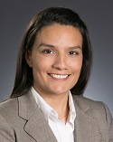

Martha Guzman Aceves was appointed Commissioner at the CPUC by Governor Edmund G. Brown Jr. on December 28, 2016. She has focused on issues related to fuel switching, broadband access, water affordability, access to distributed solar and various other energy and telecommunications issues.
She previously served as deputy legislative affairs secretary in the Office of the Governor since 2011, focusing on natural resources, environmental protection, energy, and food and agriculture. Commissioner Guzman-Aceves was the Sustainable Communities’ Program Director for the California Rural Legal Assistance Foundation from 2005 to 2011. From 2006 to 2008, she worked with Swanton Berry Farm on human resources issues, including a new employee-stock ownership program. She was Legislative Coordinator for United Farm Workers from 1999 to 2005, working on labor and environmental issues. In 2010 she co-founded Communities for a New California, a charitable organization promoting increased civic engagement of under-represented communities.
Commissioner Guzman Aceves earned a Master of Science Degree in Agricultural and Resource Economics from the University of California, Davis. She also has a Bachelor of Science in International Economics from Georgetown University.

Shana Lazerow
Staff Attorney
Communities for a Better Environment

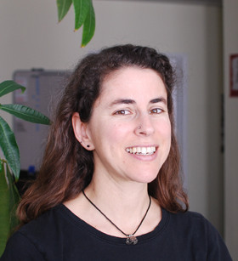

Shana Lazerow is a staff attorney at Communities for a Better Environment. She is committed to providing the legal assistance needed to bring about CBE’s vision of empowered communities and an environmentally just society. Shana brings the legal perspective to CBE’s campaign teams, and develops and pursues lawsuits using federal and state environmental statutes,. She also engages in regional and statewide policy issues including transition to clean energy.

Shana graduated from the University of Pennsylvania in 1993, and from University of California, Los Angeles School of Law in 1997. Prior to joining CBE’s staff, she was the program director for San Francisco Baykeeper and a staff attorney at Waterkeepers Northern California, where she ran a small legal clinic to train public interest lawyers. In addition to her advocacy, Shana has taught at Stanford Law School, and cherishes the prospect of helping the next generation of activists and lawyers develop strategies to bring about social change.

Mary Nicely
Senior Policy Advisor to
State Superintendent of Public Instruction
California Department of Education

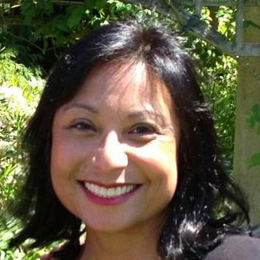

Mary serves as the Senior Advisor to State Superintendent Tony Thurmond and leads his Office of Initiatives. She most recently served as Chief of Staff and District Director to then-Assembly Member Thurmond, representing California’s 15th Assembly District. Prior to her legislative career, Mary was President and CEO of Nicely Done Solutions, Inc. a custom database development company headquartered in Berkeley, CA founded in 1994. She also served as the Western US K-12 Service and Support Manager for 7 of her 13 years at Apple. She is a first generation Burmese American and proud product of public schools graduating from Monterey Peninsula Community College and U.C. Berkeley with a degree in Political Economy of Industrial Societies.

Mad Stano
Energy Equity Senior Legal Counsel
Greenlining Institute

Mad Stano is Energy Equity Senior Legal Counsel at the Greenlining Institute in Oakland, CA. Mad started a legal career as an attorney with the Center on Race, Poverty & the Environment, where they worked with residents impacted by oil and gas pollution in the San Joaquin Valley through litigation, administrative advocacy, state and local policy work, organizing and storytelling. Mad previously worked as a program director at the California Environmental Justice Alliance supporting their climate justice, energy equity and land use state policy, regulatory advocacy and program administration work. Their litigation, legislation and work experience include anti-discrimination, land use, climate change, extreme energy extraction, decarbonization and a community-led just transition away from fossil fuels.
Mad grew up in Metro Detroit, and received a bachelor’s degree in Sociology from the University of Michigan Honors Program and a Juris Doctorate from the George Washington University Law School.

Ruth Stoner Muzzin
Partner
Friedman & Springwater, LLP

350 Sansome Street  Su i t e 800  San Francisco, California 94104  T 415.834.3800  F 415.834.1044  rmuzzin@friedmanspring.com  www.friedmanspring.com | 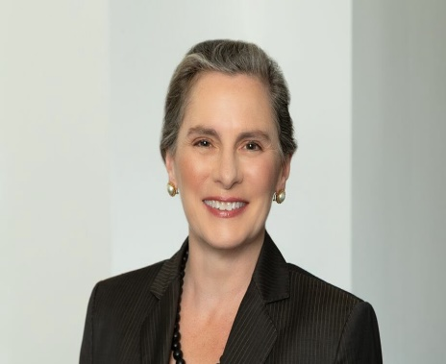

Ruth Stoner Muzzin is a partner at Friedman & Springwater LLP in San Francisco. Her practice is focused in the energy, water, transportation and telecommunications industries, and related business and environmental issues. She has represented clients in state and federal courts and before the California Public Utilities Commission (CPUC). Ruth was a member of the plaintiffs' team in multiple actions by major electric companies and state agencies to recover overpayments made to the United States, several cities, and many municipal utilities during the 2000-2001 California energy crisis, for the ultimate benefit of utility ratepayers.

Ruth’s litigation practice includes appellate appearances before the state and federal courts. She is particularly experienced in the special practice area of petitioning for judicial review of CPUC decisions, including original petitions to the California Supreme Court in CEQA matters and water utility cases. She has represented government entities, industry groups, private parties and utilities before the CPUC and other administrative agencies as well as in the courts. Ruth is experienced in litigating questions of jurisdiction and preemption in the trial and appellate courts, as well as compliance with the California Environmental Quality Act (CEQA).

Ruth was named as a Rising Star in Northern California by Super Lawyers in the area of Energy and Natural Resources for 2019 and 2020.

Ruth’s practice also encompasses insolvency and commercial bankruptcy litigation, and
navigating creditors’ rights issues, including claims litigation, fraudulent transaction matters and other related subjects. As part of this practice, she successfully defended alter-ego claims brought against numerous, affiliated legal entities in a complex administrative law proceeding, and she recently obtained complete dismissal of RICO-related claims against a company and its officers.

Ruth is member of the State Bar of California; she is admitted to practice before the federal courts for the Northern, Eastern, Central and Southern Districts of California, the Ninth Circuit Court of Appeals, the Court of Federal Claims, the Federal Circuit Court of Appeals, and the United States Supreme Court. She is a member of the American Bar Association and its Section on Environment, Energy and Resources as well as the Litigation and International Sections. Ruth serves on the Board of Directors of the Conference of California Public Utility Counsel, where she held the office of President for 2019.

